**MOBILE COMPUTING NOTES**

**Instructor Name:**

Sir Haq Nawaz

**Submitted by:**

Hina Javed

**Roll number:**

BSEF18A026

**LEC 2:**

**Version Control Systems**

**What will we learn?**

* Version Control Systems
* Concepts like Online Editing and Merge Conflicts
* Different cmd commands
  + git-add
  + git-commit
  + git-status
  + git-push
  + git-pull
  + git-log
  + git rm
  + git-branch
  + git-checkout
  + git-merge

**What is VCS:**

**Version control** is a **system** that records changes to a file or set of files over time so that you can recall specific **versions** later. Using a VCS also generally **means** that if you screw things up or lose files, you can easily recover.

### Why do we need it:

* To keep track of changed to code.
* To make same code available to all members working on a project.
* To synchronize code between groups.
* To test changes without losing original files.
* To revert back to old version.

These notes are made in step by step format. Steps with screenshots are attached with proper explanation.

**STEPS:**

1. Go to github website (<https://github.com/>) and sign for free.

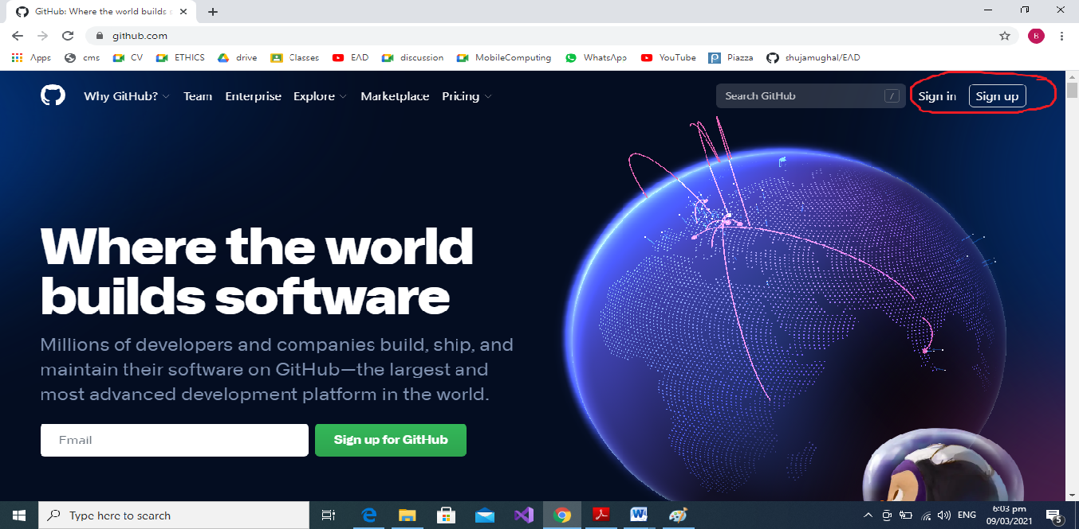

2.Make a new repository.

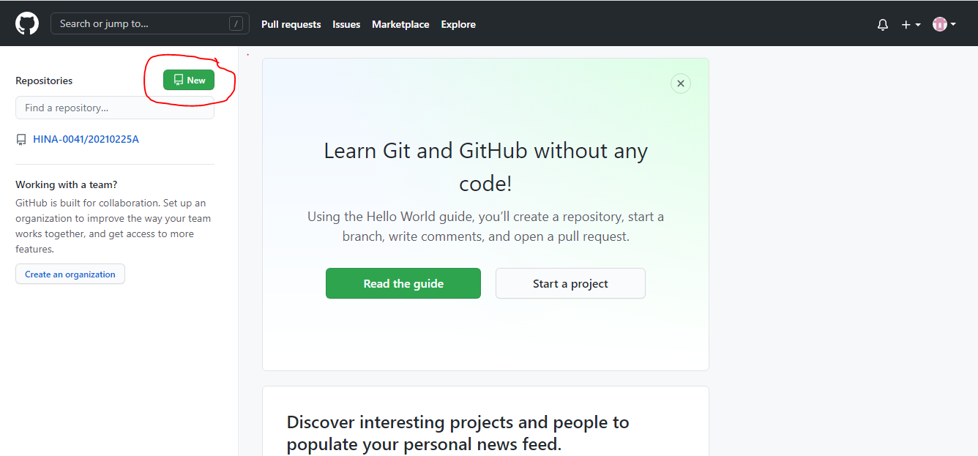

3.Give it a meaningful name. I am giving “MC_Progress”.

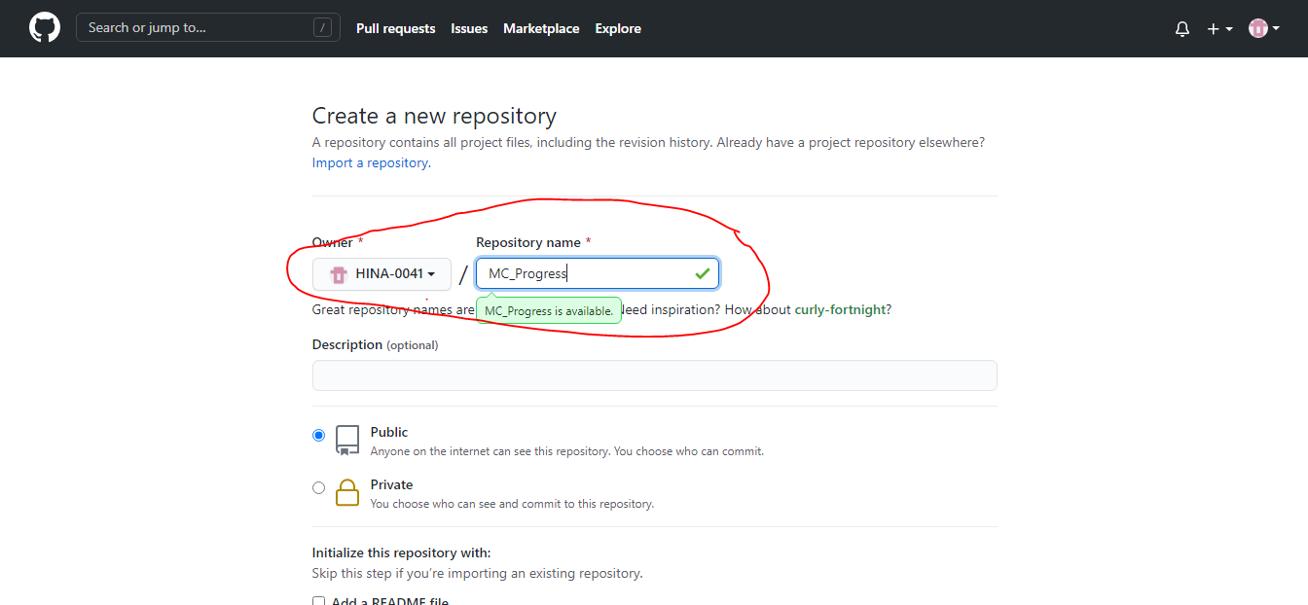

4.After configuring press “create repository” button.

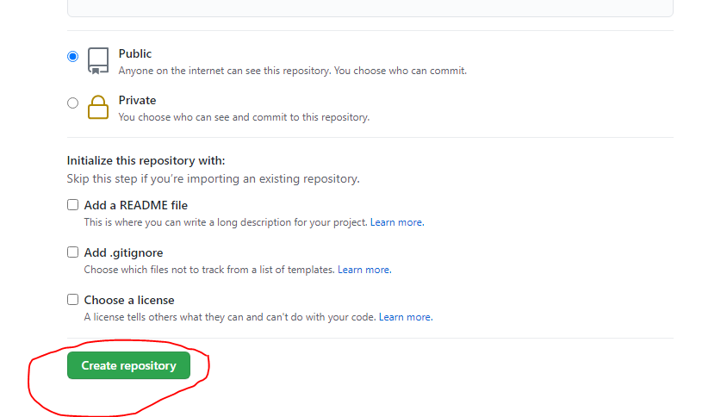

5. Copy repository link. We need it in coming steps.

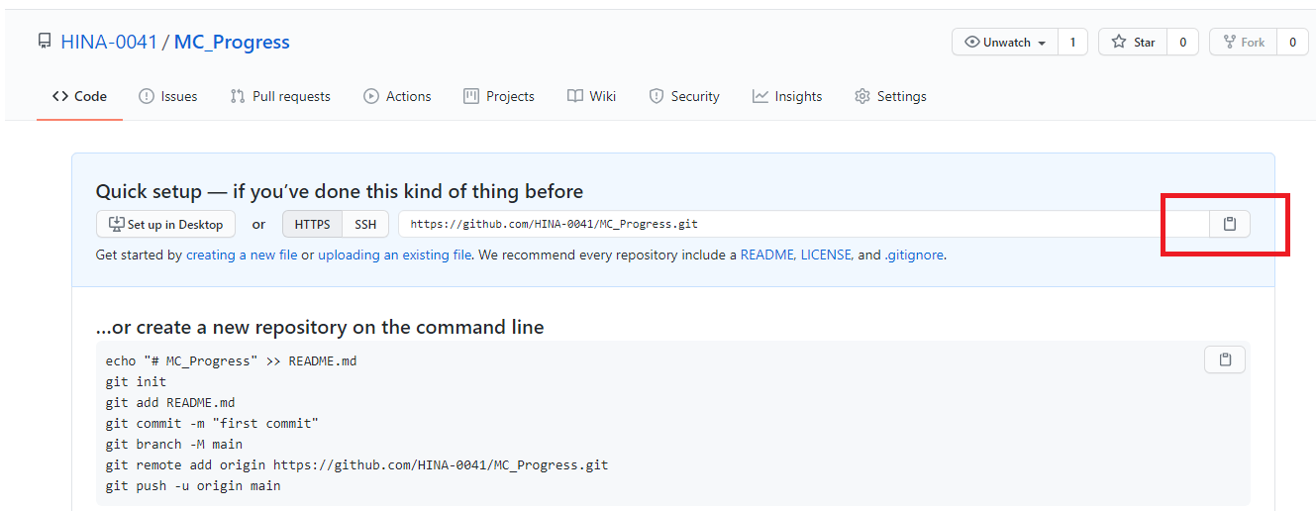

6.You must install git in you machine. Type “git install” on google. Download and install it.

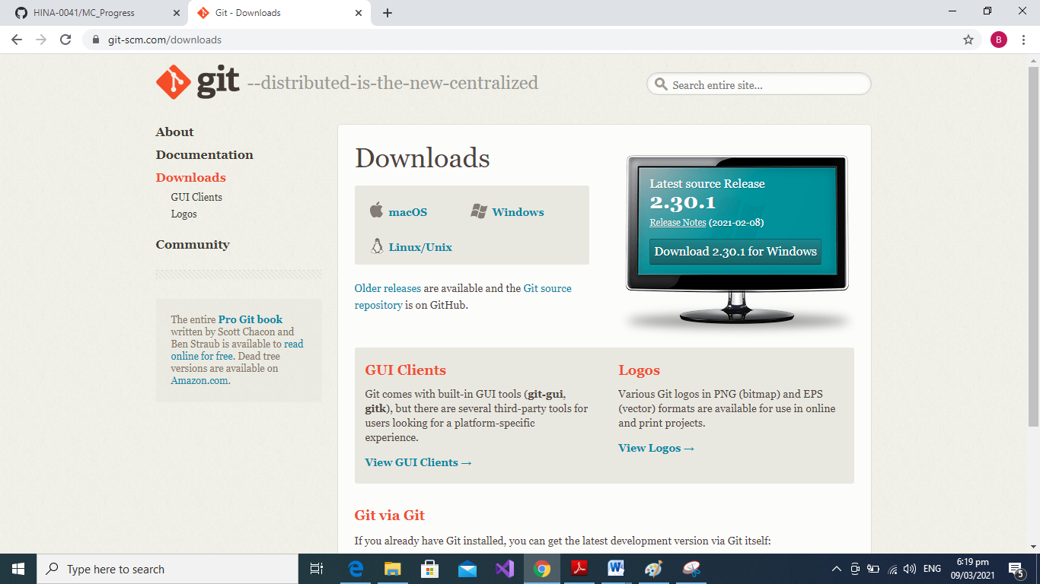

7.Now make a folder named as git.

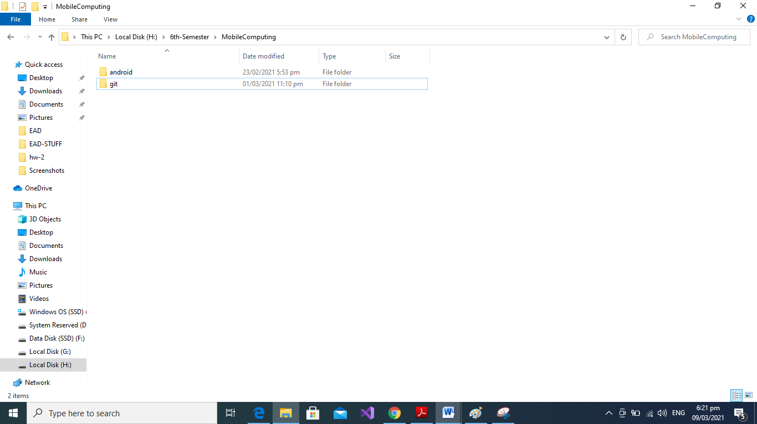

8.Now open cmd (run as administator)

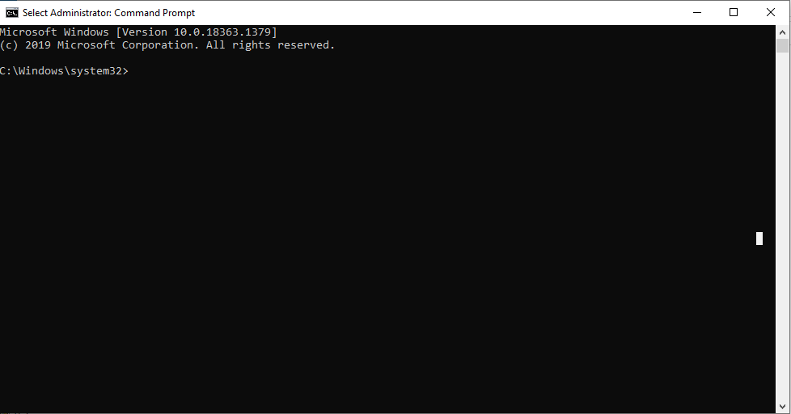

9.Use cd command and go to desired directory.

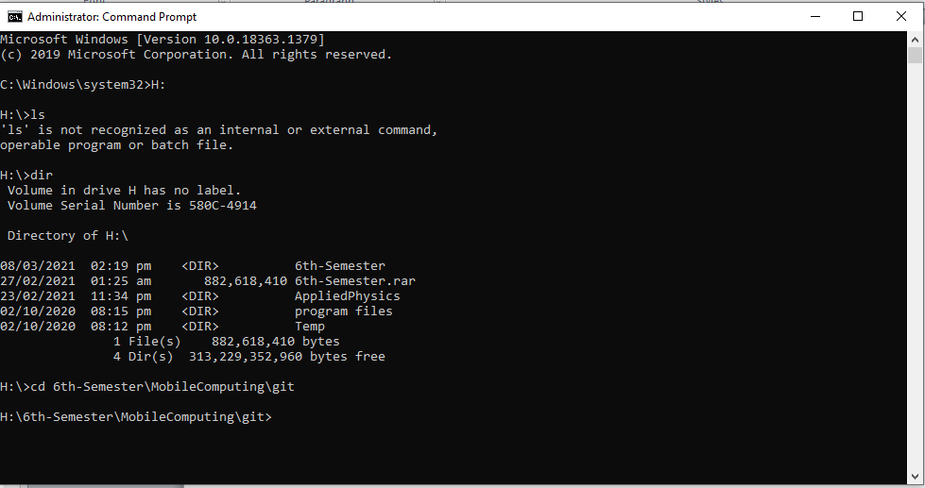

10.Write “git clone [url]”. Paste the link that is copied.

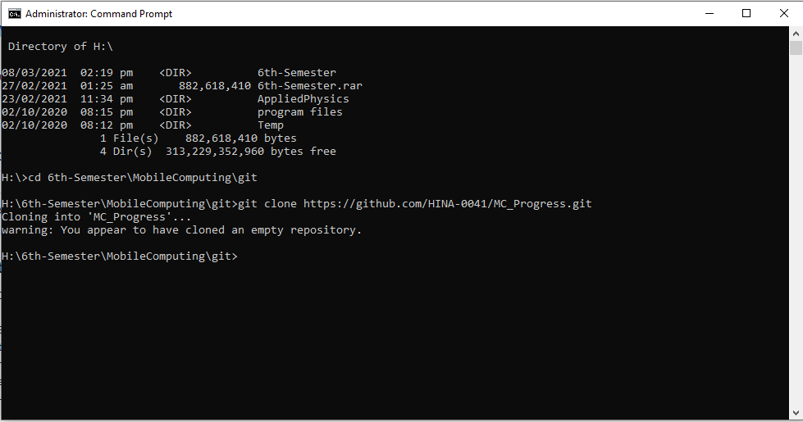

11.A folder is automatically created with the name of the repository.

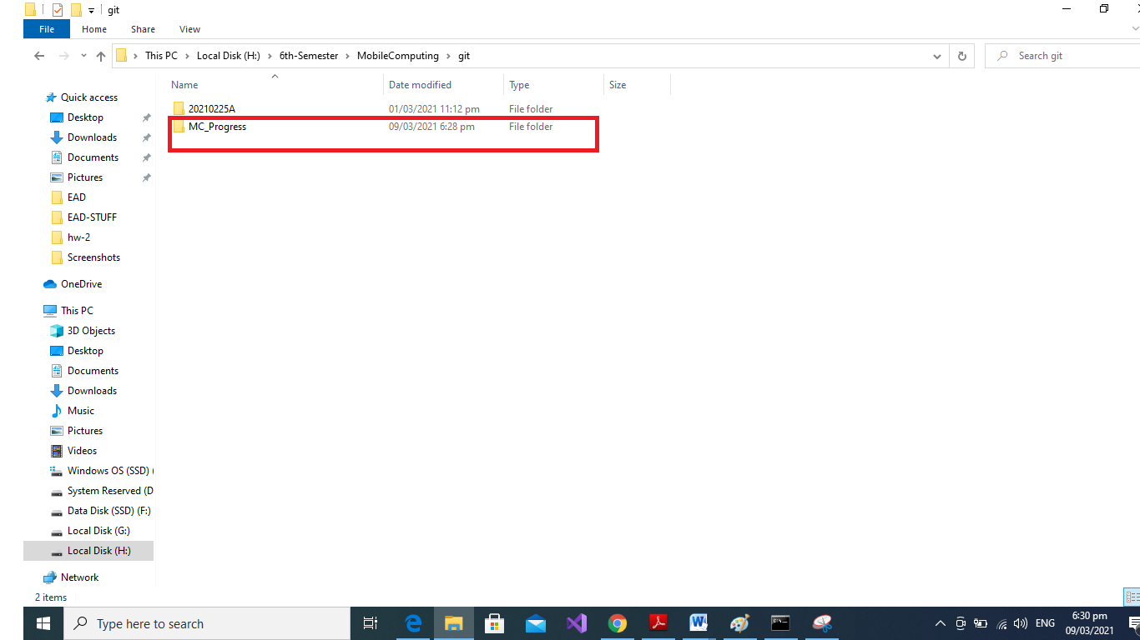

12.Now make a .txt file to understand the link with repository. Go to folder MC_Progress using cd.

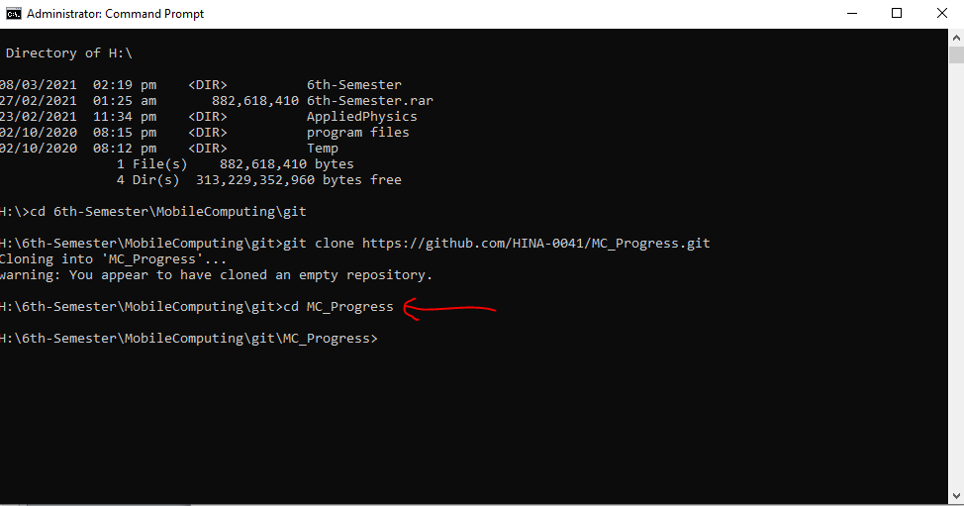

13.Write “git add [filename]”.

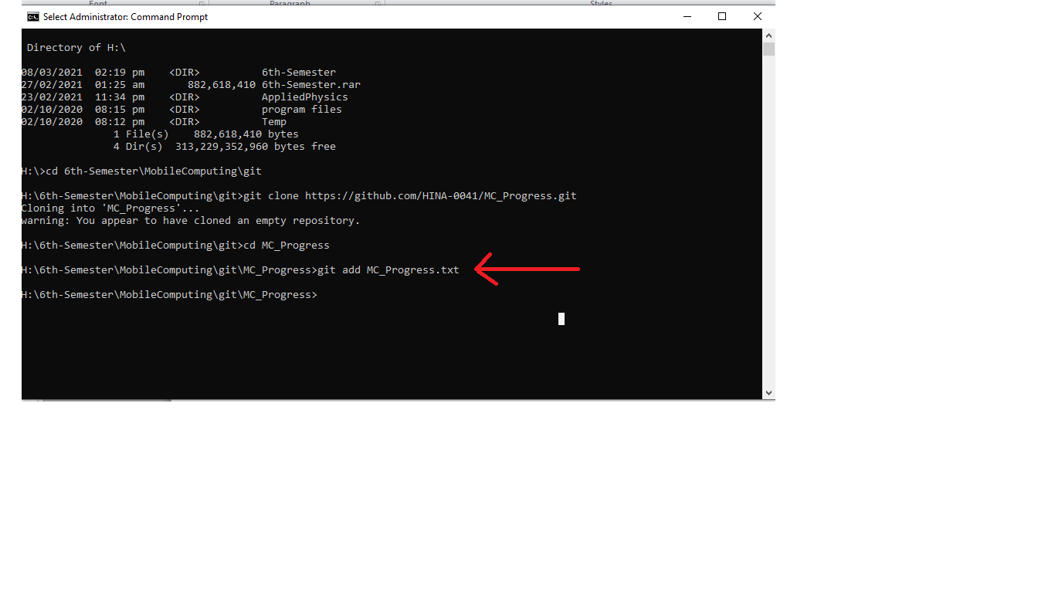

14.Now type “git commit -m “Message” ”.

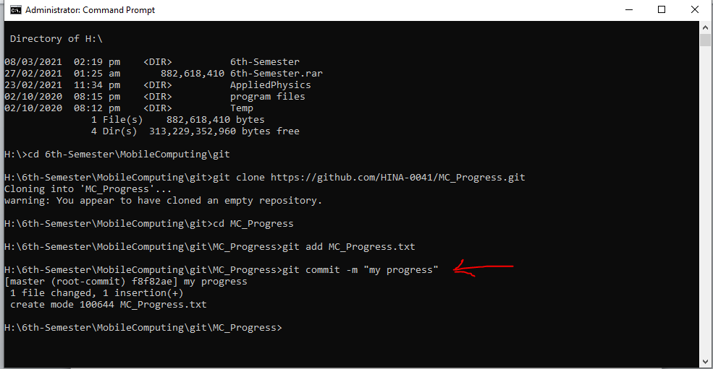

15. Now push the file to the repository by typing “git push”.

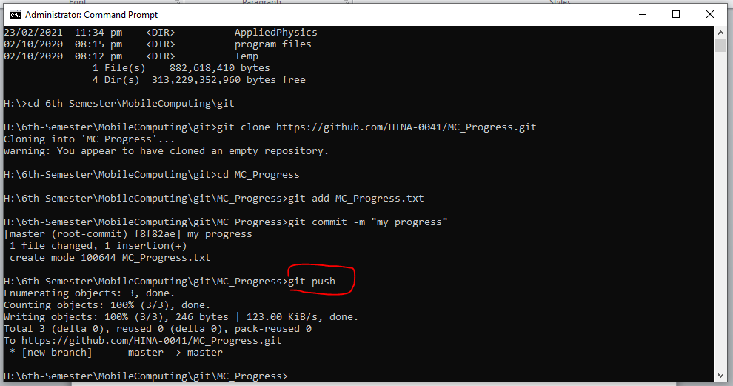

Now you can see the file in online repository.

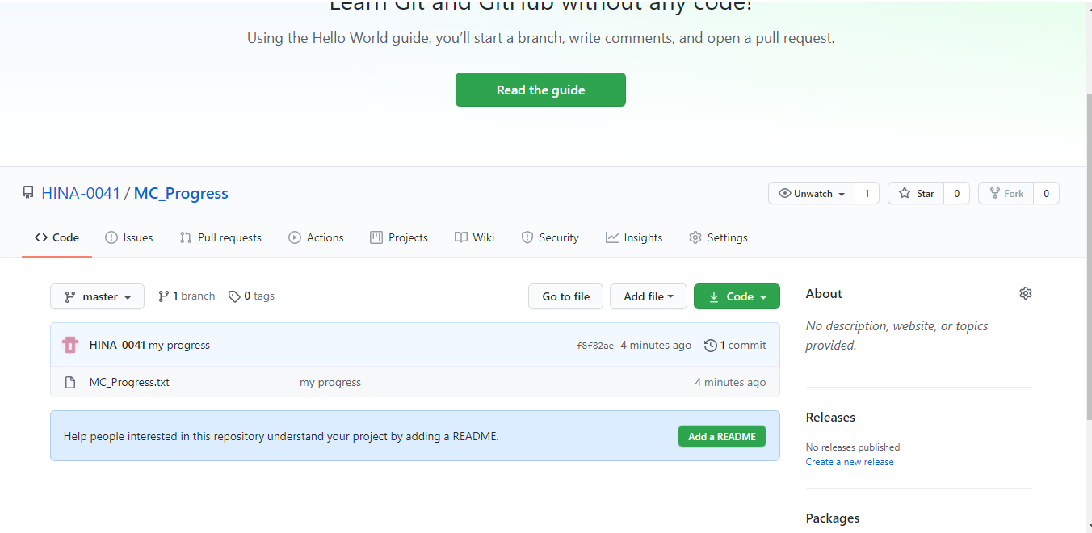

16.Today almost every IDE supports github and tells that we have made changed to the file. Lets open the file in VS code. When we write a line message pops. It also tells all the versions of our file.

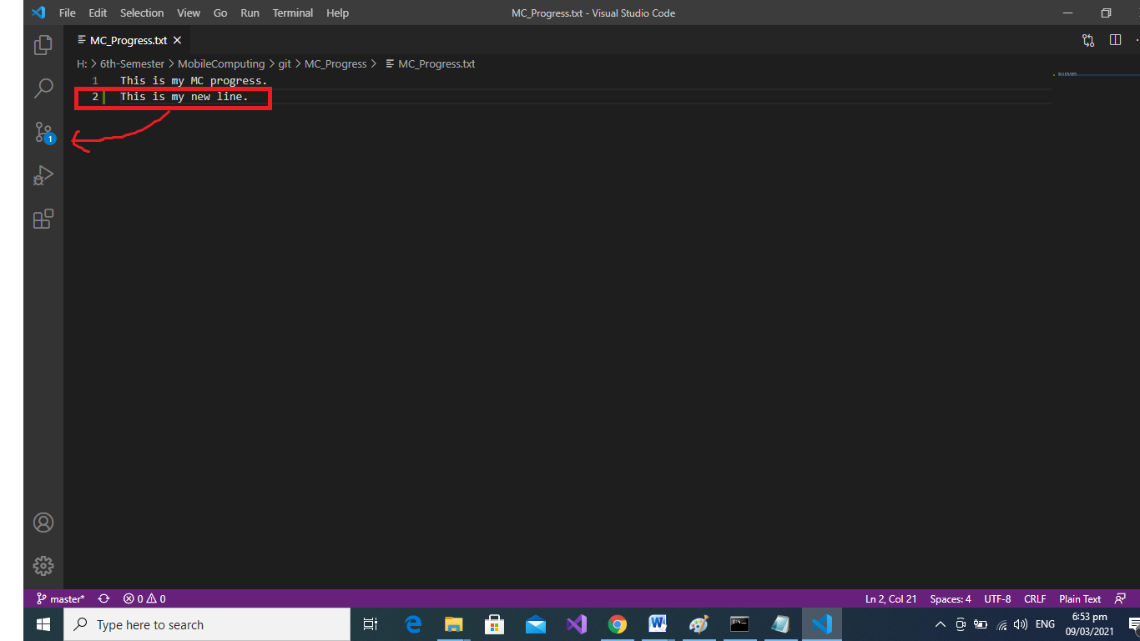

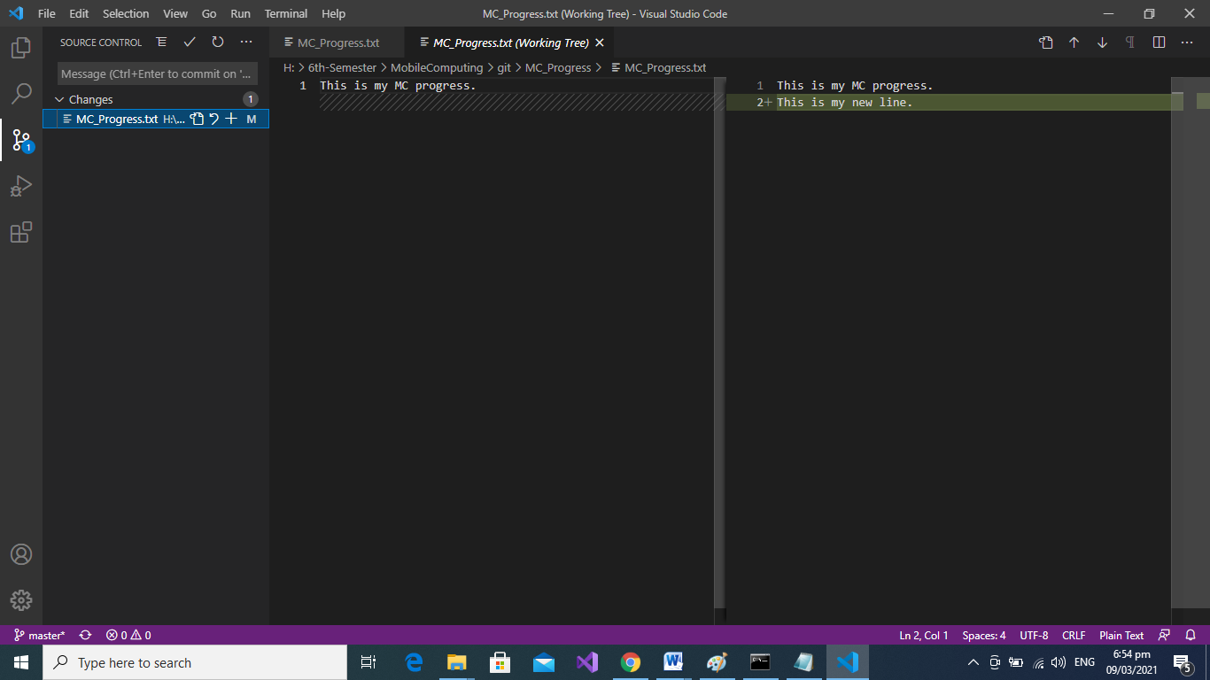

17.Moreover when we push the updated file by repeating same steps.We may see parent (previous versions) of our file

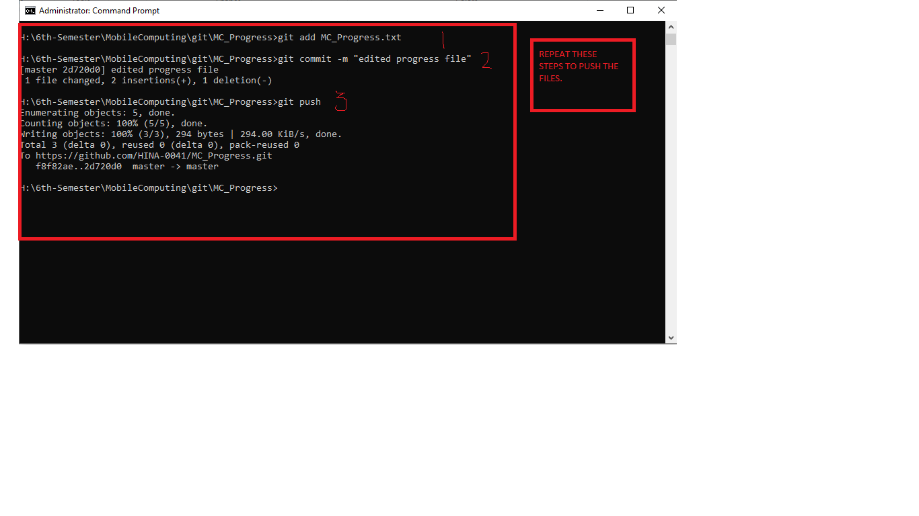

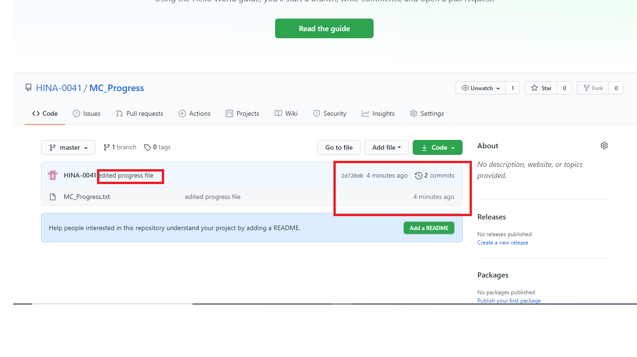

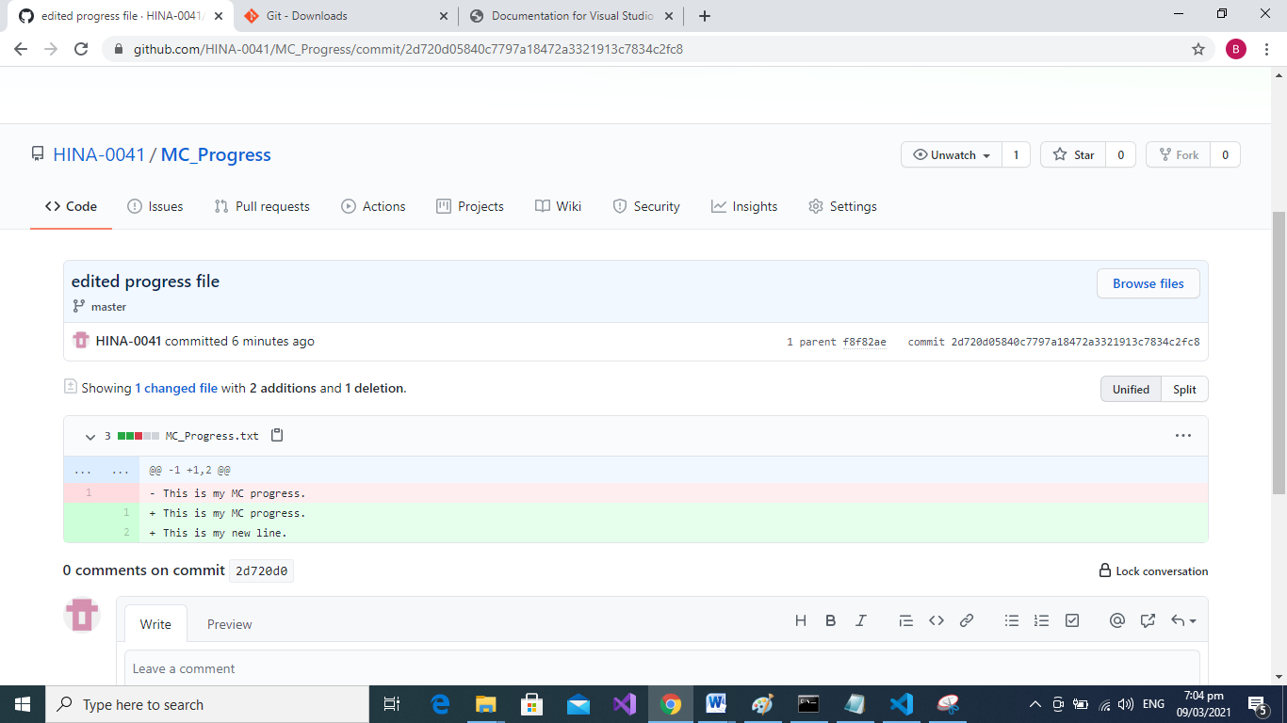

**LEC 3:**

## Click on the pen like icon and modify your files as required. Scroll down and click “commit changes” button.

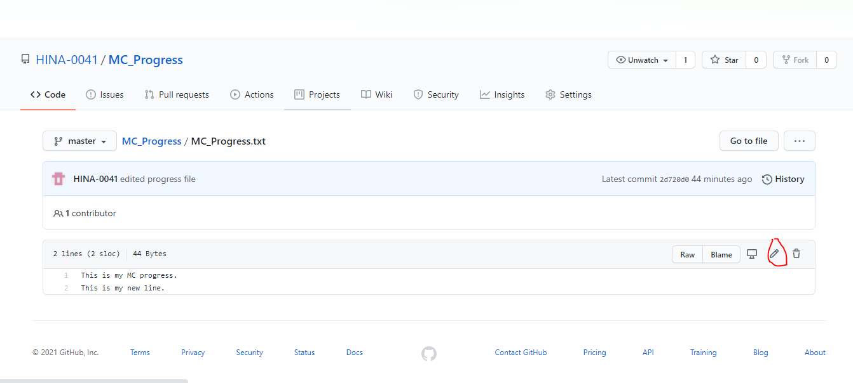

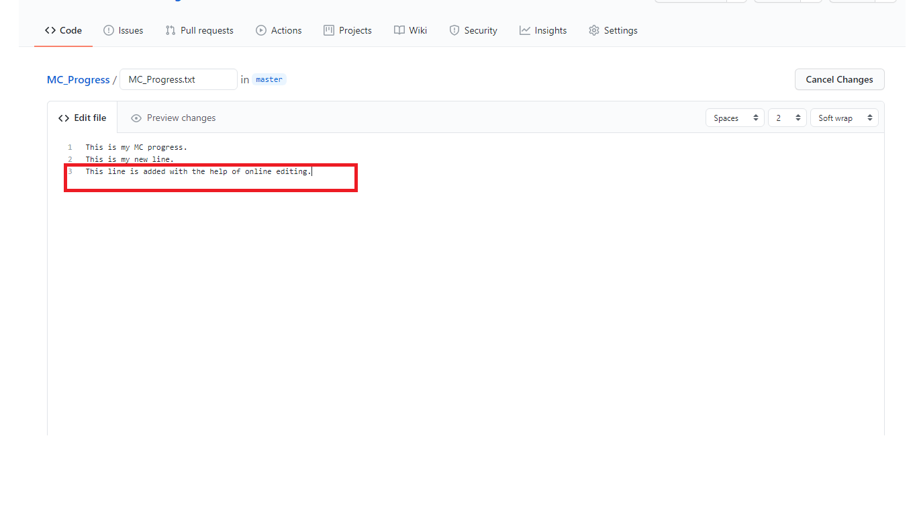

1. Now we will use “git pull” command. It is used when we want to synchronize data i.e take data from online repository to our local machine.

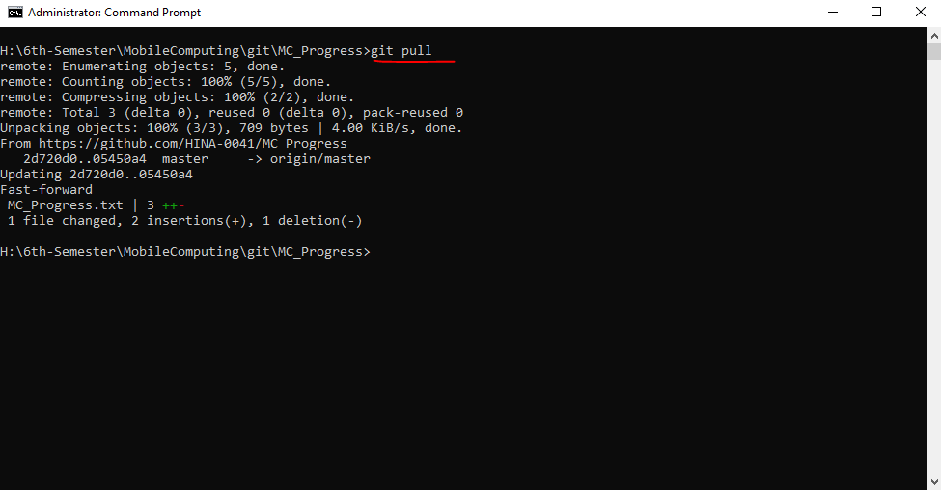

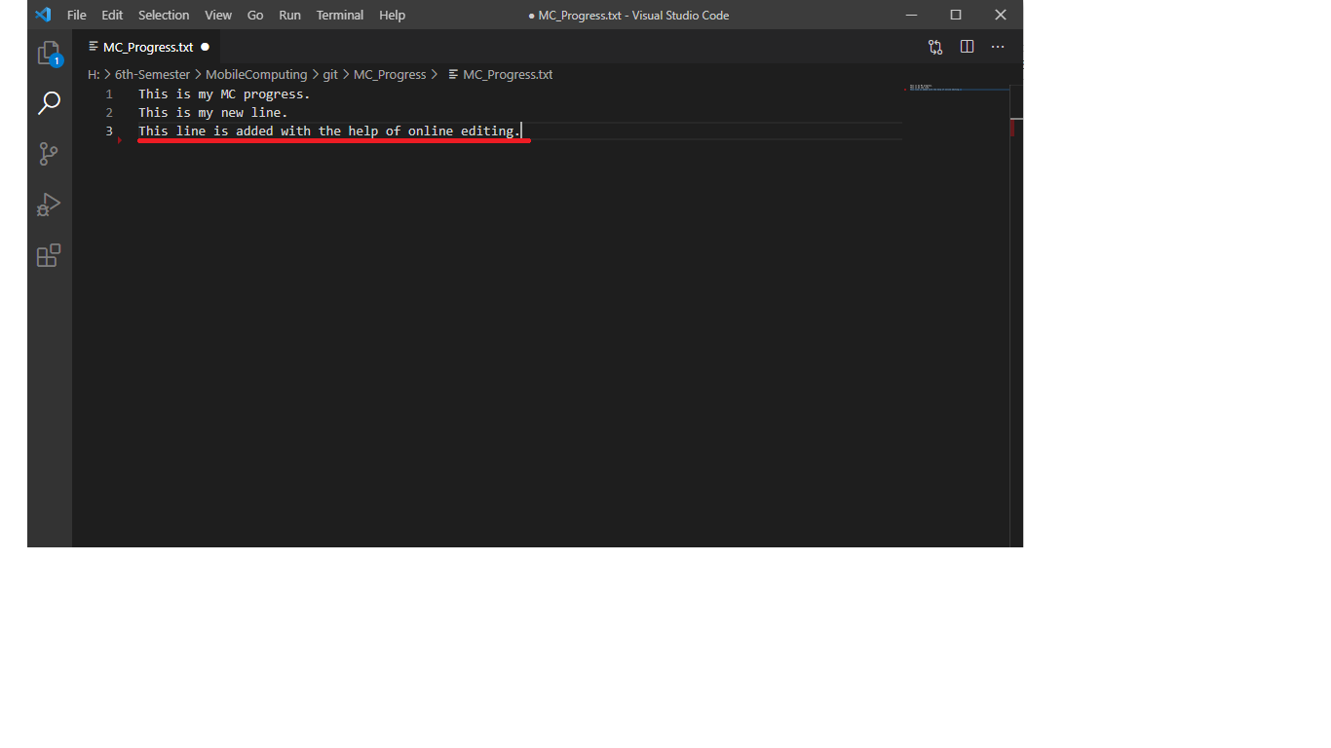

**Merge Conflicts**

It is very important concept. It arises when same line of code is being changed by two users. We will understand it by experimentation.

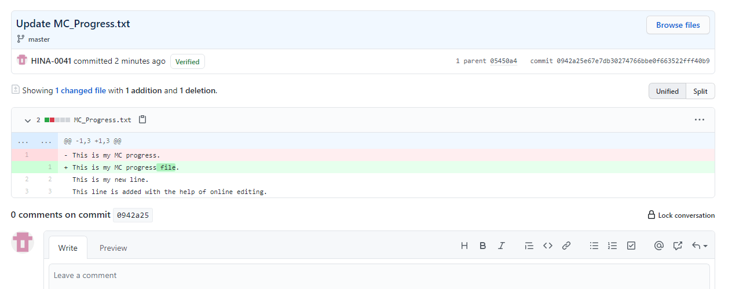

We got error so we resolved our merge issue in VS code and re pushed the file.

